* **Creating Data frame from Dictionary**

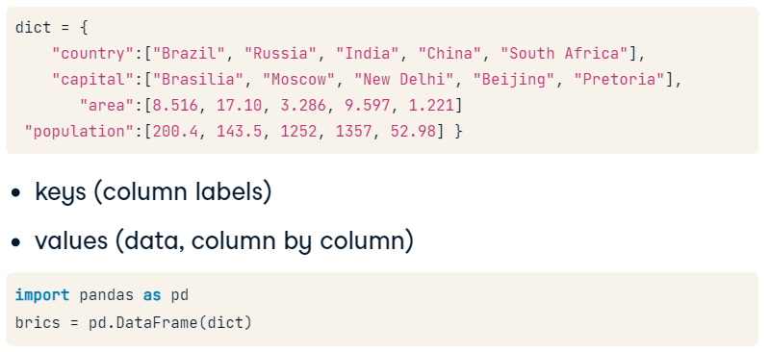

* **Specify Row Labels Data frame manually**

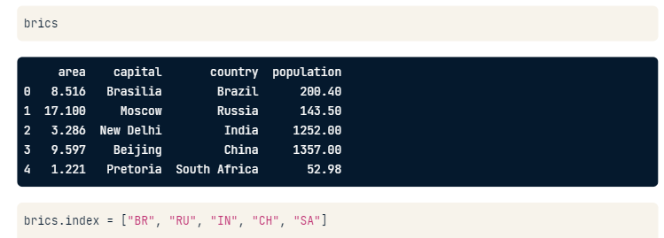

* **Import Data frame from CSV file**

#Set the first column as the row indexes

Import pandas as pd

dataFrame = **pd.read_csv**(“path/tp/brics.csv”, **index_col** = 0)

* **Index and Select data**

**# Column Access (this prints out the entire column, but the result is not a Data Frame but Pandas series)**

brics[“country”]

**# Column Access with double square brackets (this keeps the column in the Data Frame)**

brics**[[**“country”, “capital”**]]**

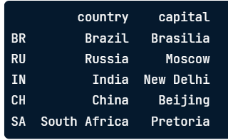

**#Row access (this prints out the 1st, 2nd, and the 3rd row)**

brics[1 : 4]

**# Row access loc (this finds the locations of the rows and print them out)**

brics**.loc**[[“RU”, “IN”, “CN”]]

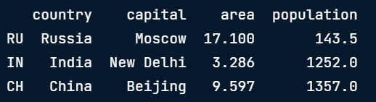

**# Row & Col loc (this prints out the Data Frame that spans all rows and 2 columns)**

brics.loc[ : , [“country”, “capital”] ]

# Remember, iloc deals with indexes

**# Row & Col iloc (prints out selected rows and columns)**

brics.iloc[ [1, 2, 3], [0, 1] ]

**# Selecting specific observations for a country**

cars.loc[['IN', 'RU'], ['cars_per_cap', 'country']]

